**High Probability Daytrade Setups**

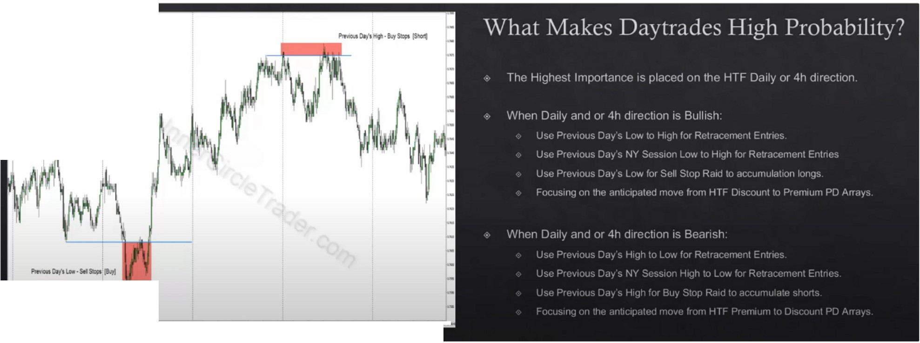

When we look for high probability trades, we ask ourselves where is price likely headed to? Higher or lower? And off of what level? And what level is it reaching for for profit?

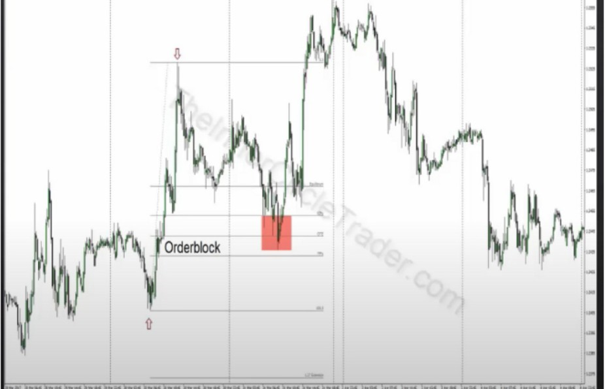Besides those sessions, also use previous day's London session highest high and lowest low And the previous London session high and low prior to the new york session

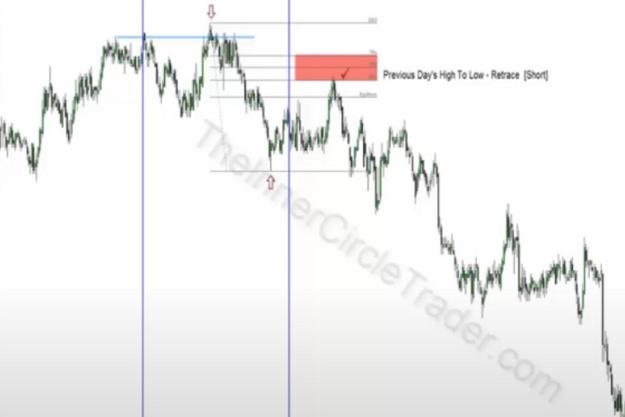

On the L**TF** we look for the same things we looked for on the HTF in the previous months

These criteria is not every possible scenario, these are the things ICT looks every single day when the conditions are right. When he's done his due diligence on the **HTF** and hes arrived at what he thinks is the highest probability direction, use the previous models and previous months for bias. And the IPDA data ranges with the PD array matrix

Measure the london session range to right before the new york open the extreme high and low, thats important to know befor the new york session, if were bearish then that range is going to help find the next trading day retracement up. During the protractionary state, that move up is going to be a retracement into that london session range from london going into the beginning of new york, so 2am to 7am

Also measure the new york session range high and low, that will also many times give the setup frame for the next days high or low, there will be a retracement inside that range

Look for the previous day's high and low to look for stop raids, generally youre going to see those scenarios occur when there is an end to a most recent move, in other words when weve seen several days go up its going to go up into a premium array and its probably going to trade above an old high then look for a buy stop run there and then go short the next day, vice versa when the

market has been trading lower into a discount array and we look for the market to trade down below a previous day's low then buy the sell stops and use that as a daytrade

Daily and 4h when we use those independently or in cocert with 1 another to build our bearish or bullish ideas, what were looking for is price analysis of seeing is price supporting bullishness so is it bouncing off of bullish orderblocks is it rejecting old lows and showing a willingness to go higher is it filling in gaps below us and then rallying? Those ideas are the first things that we look for, then are we seeing short term premium arrays getting violated? If thats occuring then its bullish, institutional orderflow is bullish. Vice versa for bearish

When

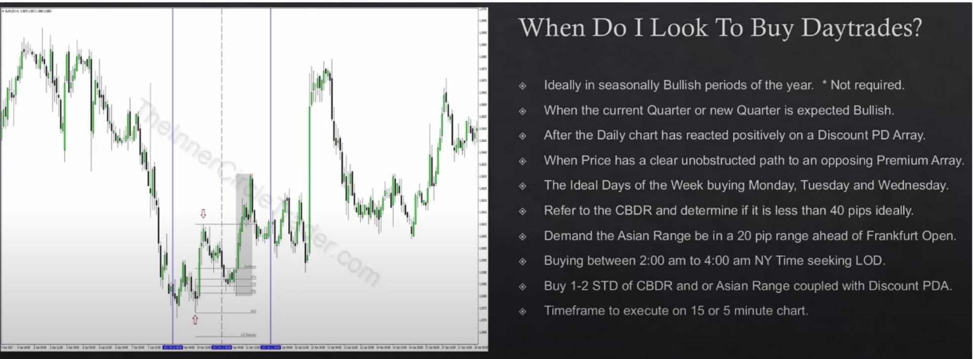

Its easily seen what it would reach for above you presently, if you cant see it easily its probably not going to be a high probability setup

Where

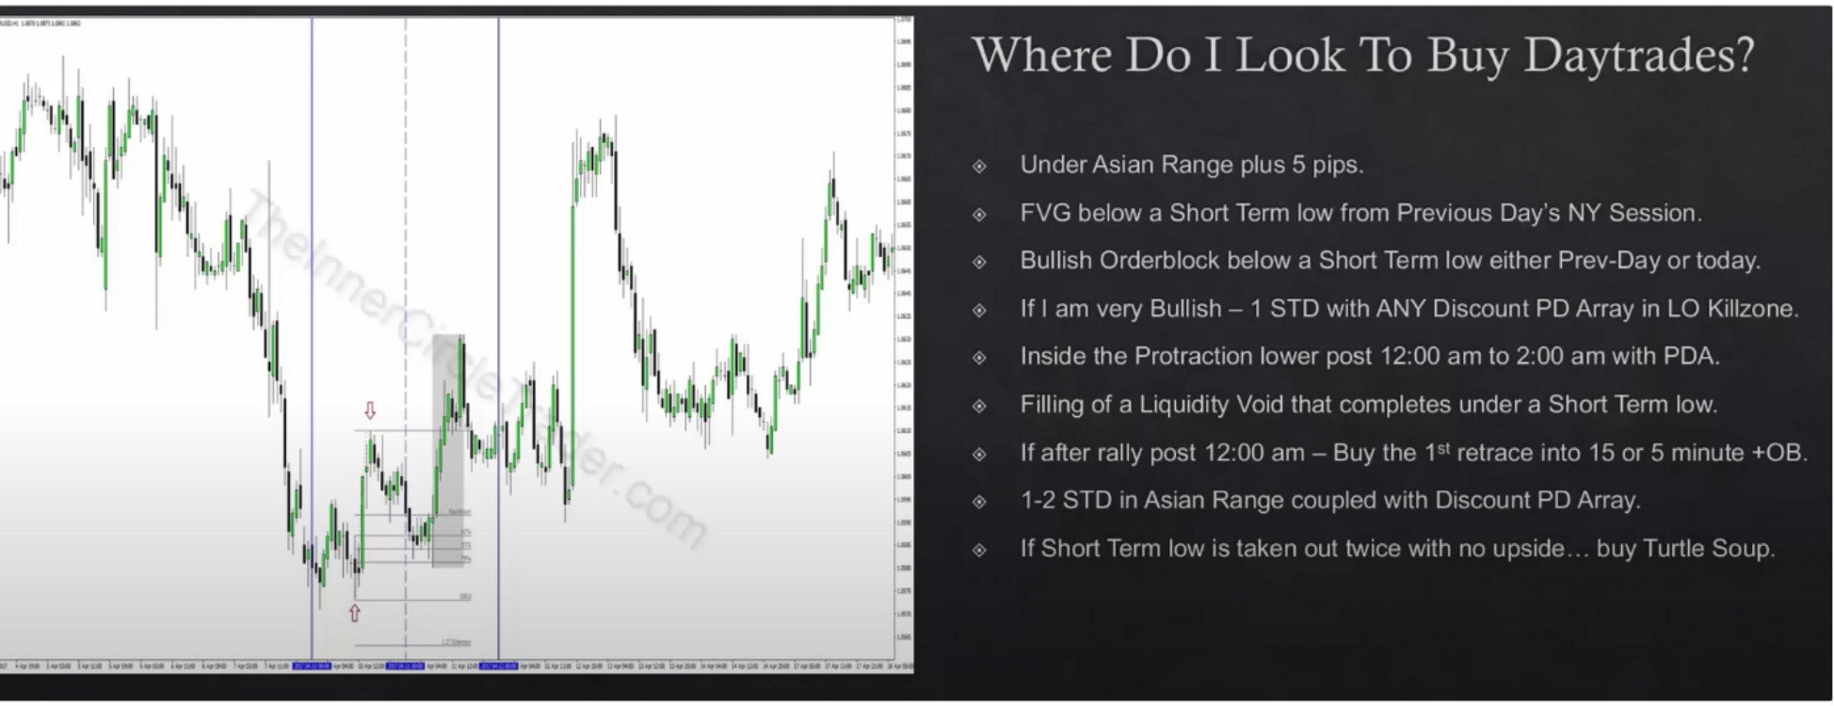

FVG below a short term low from previous days NY session obviously has to line up with other things as well, like the CBDR, asian range etc. And time of day, during London open

If we have rallied right after MNO and didnt get any retracement then at 2pm we buy the first bullish orderblock on the retracement on a 15m or 5m timeframe

We havent seen the market go up first then go down twice the second in that condition the market is likely going to keep on going lower. If it has not seen any protractionary move on the upside or a judas swing up and we go down for a low and 1 more time blow out that low we buy that as a turtle soup. This one is not really clear to me?

These are the scenarios ICT loves to trade london open, these kind of trades form several times a week. If you look for a few of them when the market is bullish and we show willingness to respect the daily discount array. One of these criteria is going to meet, every london session out there will have something in this list that forms.

If you study them, they all dont have the same characteristics, it depends on what the market is providing you. When were watching at 12am MNO were watching which scenario unfolds, were looking for that protraction at 12am but if it doesnt happen we have that condition here if it rallies straight from 12am when we get to 2am we buy the 1st retrace into 15m or 5m OB

We got every scenario on here that we would be looking for

Placing stoplosses in buy daytrades

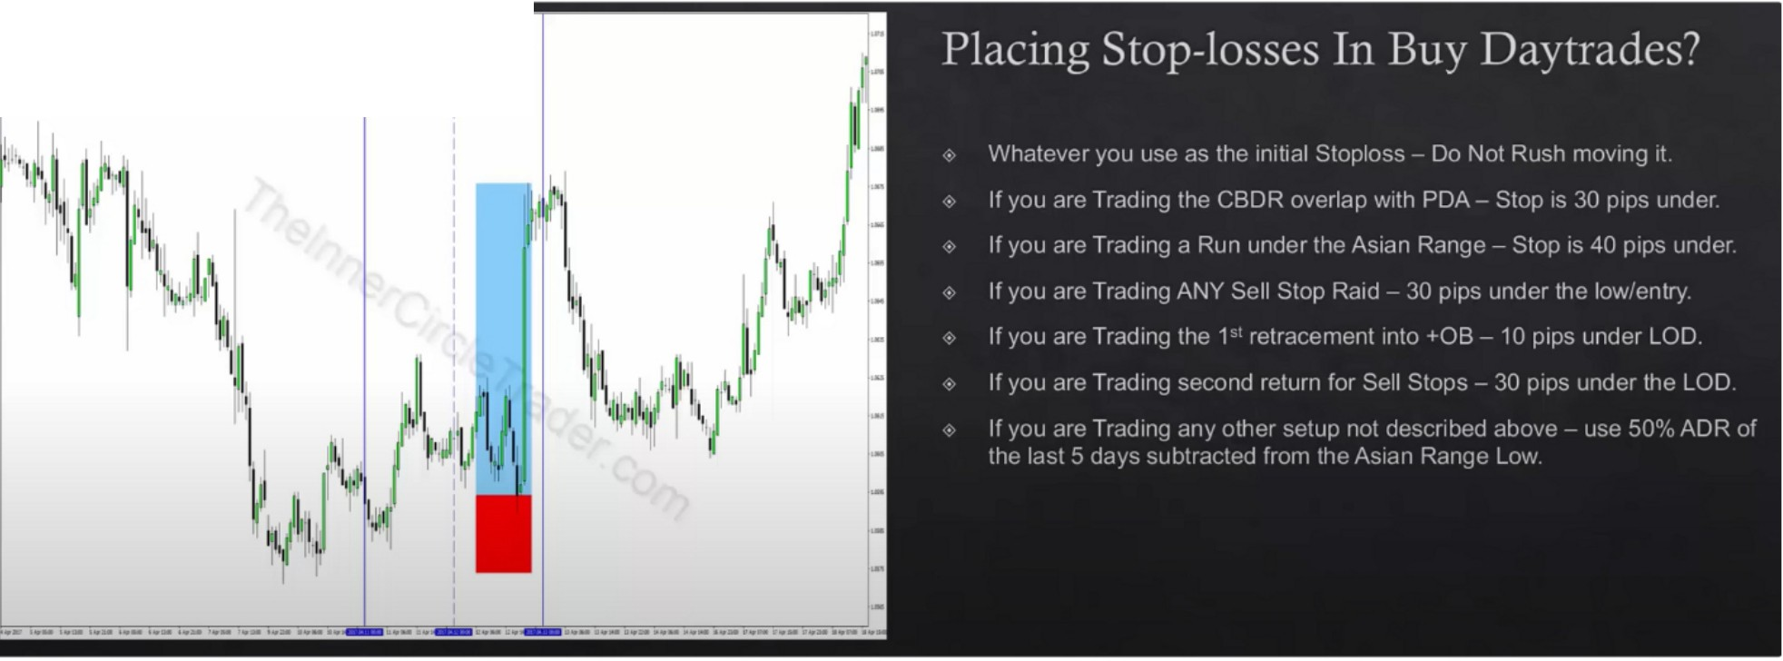

Tuesday W-

London can come back with a double pass, might knock you out at BE and you miss the move, so dont rush moving your SL. Leave it until you get atleast 40-50% of the daily range and then put it at BE

"If youre trading second return for sell stops" Thats when we have a move lower and then it moves lower 1 more time and takes out the sell stops your stop has to be below that with 30 pips. Again that one is if you dont see any move right away after MNO if its only been a straight downmove and then it goes down one more time below the low its formed initially your stop has to be 30 pips below that if youre buying that as a turtle soup

For the last one: Assume we have a 100 pip ADR over the last 5 days, take 50 pips minus the asian range low, whatever that price is thats what your stop loss has to be

Taking profits in buy daytrades

In time of day short term high, whatever that short term high is prior to 7am you want to take something off as NYO is rallying from 7am to the short term high or above it, because New York can be a reversal

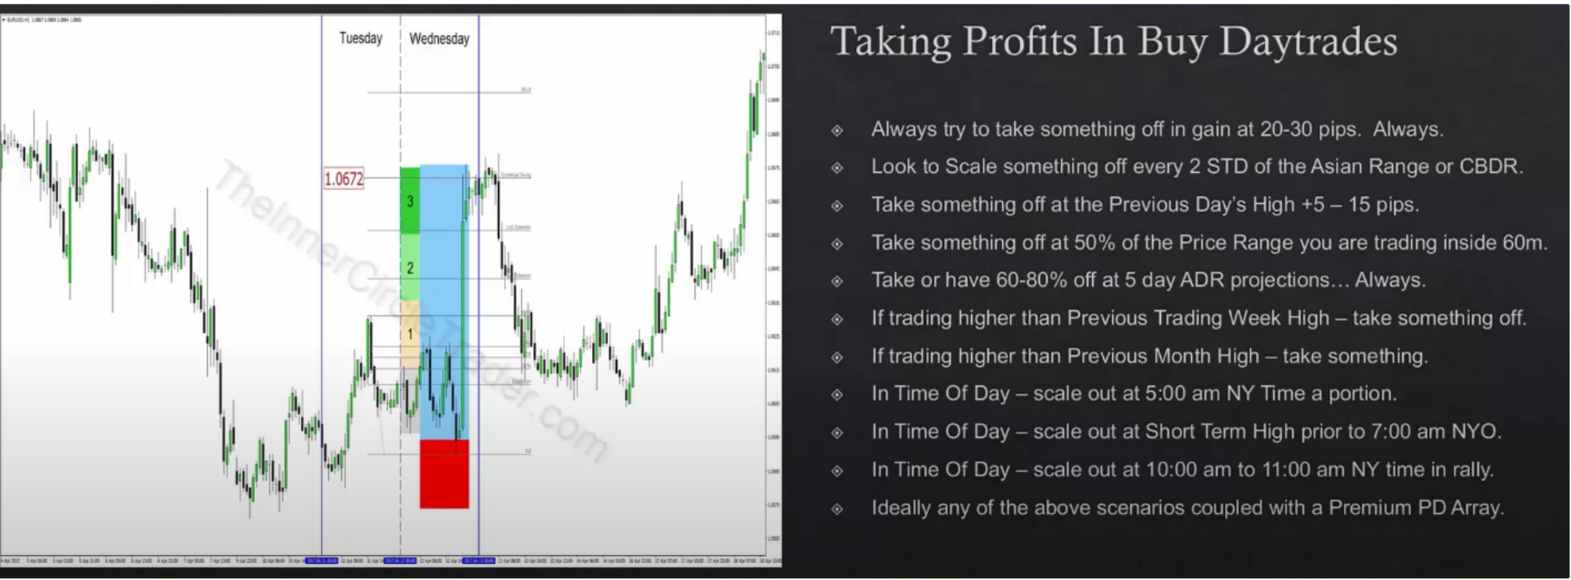

Not all these conditions can be present, but you want to look for the ones that may be there for you. Go trough the list before you take a trade and see if which one of these are candidates.

When do i look to short daytrades?

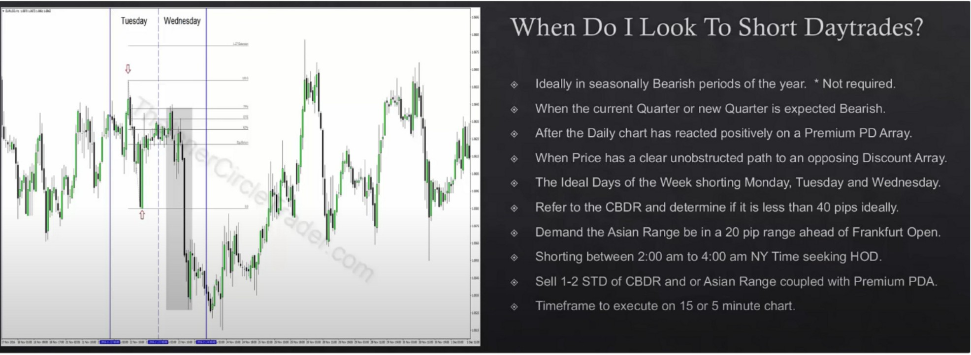

Where do i look to short daytrades?

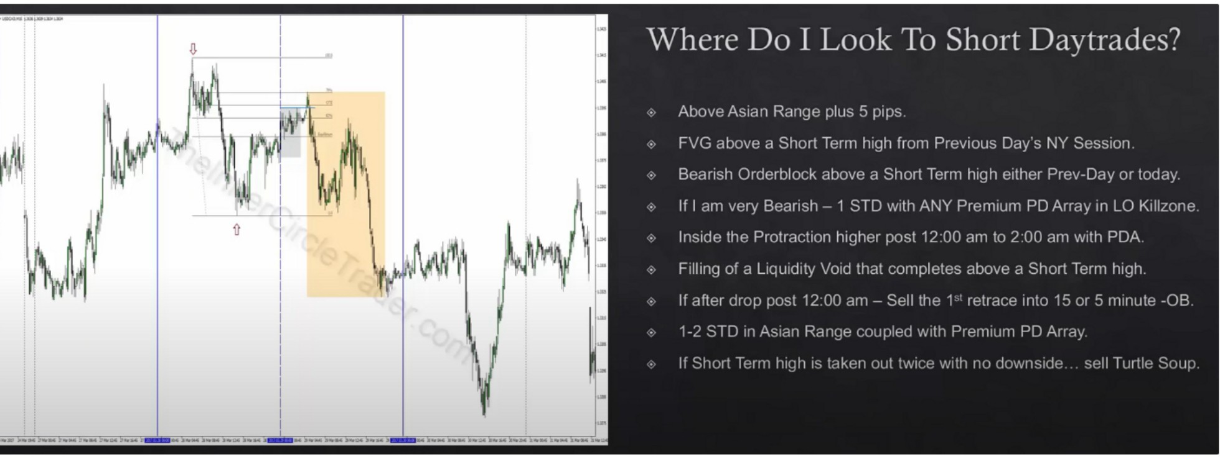

If right after 12am it goes into a PD array thats enough to go short Placing stoplosses in short daytrades

Watch out for significant lowes, because it could reject or reverse and make a turtle soup

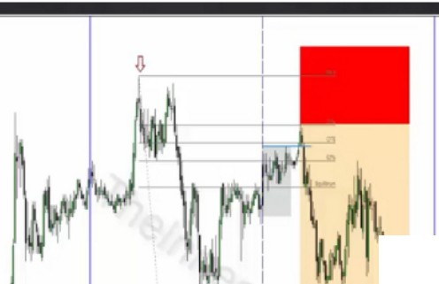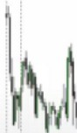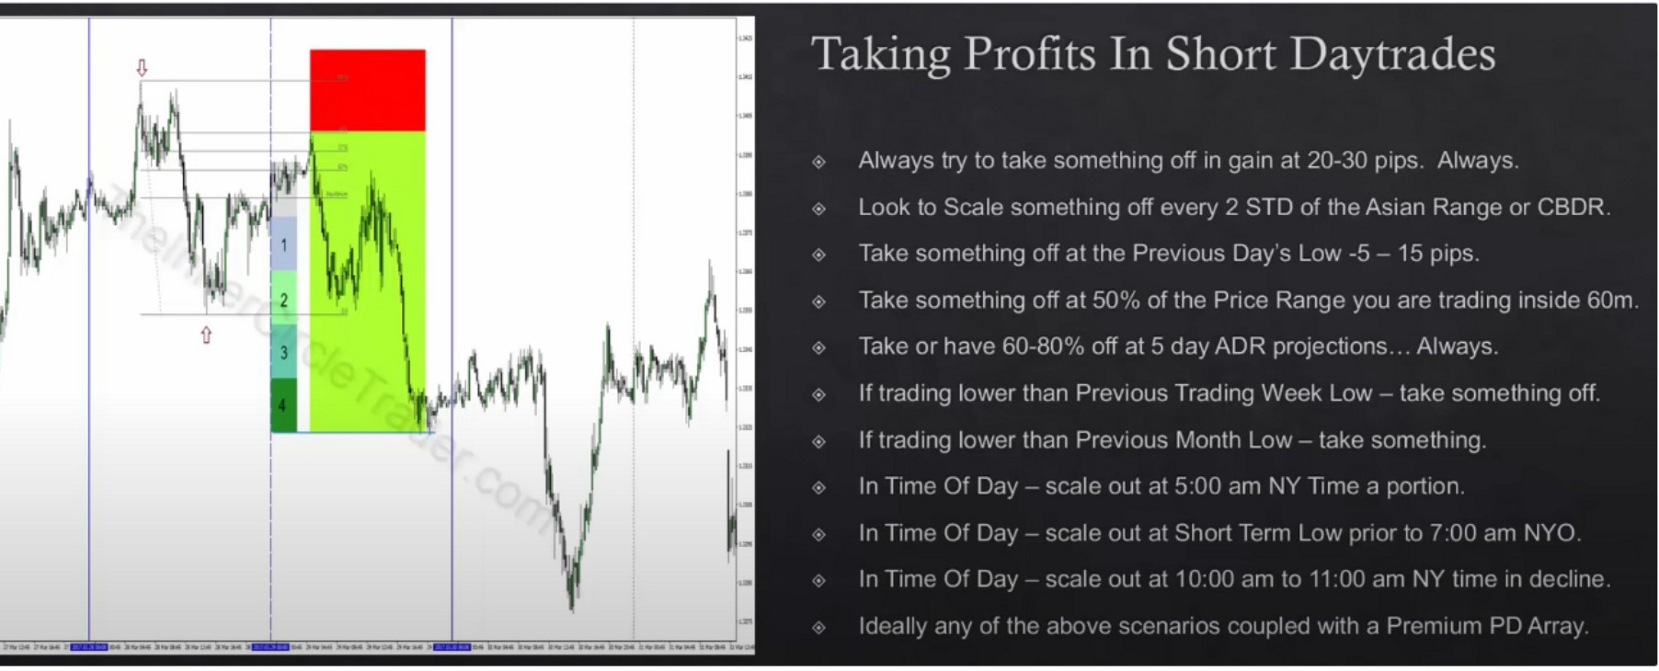

Placing Stop-losses In Short Daytrades?

Whatever you use ;=is the in1ti<1I Stoploss - Do Not Rush moving 11

If you are Trading the CBDR overlap with POA- Stop Is 30 pips nbove

If you arc Trc1d1r1g a Run c1bove the Asi;rn Rcrnge Stop Is 40 pips above If you arc Trading ANY Buy Stop Raid 30 pips above the h1gh·cntry

ltr4

If you c1re Trad1n!--l lhe 1 retracement into -OB - 10 pips cibove HOO

If you are Trad111g second return for Buy Stops - 30 pips above the HOD

If you ;ire Trr1d1WJ ctny ott1er st:tup not descr1b1!d c1hove - use 50'' ADR of

thP last 5 d;-iys c1c1c1ed to Hie As1;111 Ra11cw H1qr1

I

* ·- ·- ·- ·-. --· ··-··-- -- .........--=- ·., ·-

If you are trading second return for buystops, and we have not seen an immediate rally lower in price after MNO your stop has to be 30 pips above highest high of the day

Taking profits in short daytrades

j I

NYO could be a reversal, or a retracement into the CME opening so we want to see profit taking ahead of 7am

Should be "coupled with a discount array"

All the ones that havent been talked about here have been talked about in previous lessons, like the fibs, the symmetrical price swing or 1.27 or 1.68 those ideas amplify coupled with this

There not going to be applicable to every trade youre in, not every single one will be used in 1 trade, its a checklist. We might not even be near a monthly low, you mightve taken something already off at 20-30 pips and it hasnt moved much beyond that at 5am so you wouldt consider that one either

Theres specific rules for everything for specific scenarios

Arjo I Twitter, lnstagram I Linktree

Linktree. Make your link do more.

, https://t.co/HhmmTN1fUI

JavaScript is not available.

*"!JI* https://twitter.com/arjoio